School of Computing Science and Digital Media
Coursework Assignment

Surname | Neilson
First name | Jack
Matriculation Number | 1506801
Contact phone number | 07990850875
Course + Year | CM3
Module Co-ordinator | David Lonie
Module Number + Name | CM3033 Concurrent Programming
Coursework Title | Share Price Server
Coursework Part | 1
Due Date | 16 December 2016 at 4 pm
Declaration ** This must be affirmed by signing below
I confirm
- that the work undertaken for this assignment is entirely my own and that I have not made use of any unauthorised assistance
- that the sources of all reference material has been properly acknowledged.
Student Signature | 
Date Submitted | 2016/12/16

Marker's Comments
Marker | Grade

** An extract from the University Regulations

6. Academic Misconduct
Refer also to Schedule 3.3 of this Regulation for guidance on this procedure.

6.1 Academic Misconduct is defined as any attempt by students to gain an unfair advantage in assessments and examinations. Examples of academic misconduct include plagiarism, cheating, falsifying data, collusion, bribery or attempted bribery, personation or any other activity intended to provide an unfair advantage.

(i) Plagiarism is the practice of presenting the thoughts or writings of another or others as original, without acknowledgement of their source(s). All material used to support a piece of work should be carefully referenced and should not normally be copied directly unless as an acknowledged quote. Text translated into the words of the individual student should in all cases acknowledge the source.

(ii) Cheating includes:
- the taking of any unauthorised material into an examination;
- obtaining copy of “unseen” papers in advance of an examination;
- communicating or attempting to communicate in any way with another student during an examination;
- copying or attempting to copy from another student during an examination or in the production of coursework;
- wilful deception in any element of an examination or assessment.

(iii) Falsification of data consists of the misrepresentation of the results of experimental work or the presentation of results from fictitious work.

(iv) Collusion is the representation of unauthorised group work as that of an individual student.

(v) Bribery is the paying, offering or attempted exchange of an inducement for information or material intended to advantage the recipient in an examination or assessment.

(vi) Personation consists of a substitute taking the place of a student in an examination.

A student who aids and abets a fellow student to commit academic misconduct shall be deemed to have committed academic misconduct and will be dealt with accordingly.

Statement of Compliance

Implemented
1. A text field showing the current system time
2. A button to start the server
3. A button to stop the server
4. A continually updating readonly text area that displays the current state of the shares
5. A scrollable text area that shows the history of operations since the program started
6. Validation for user input
7. A server to handle incoming connections
8. A connection handler to take user input, parse it, and apply it to the data

Not Implemented
n/a

Analysis & Design

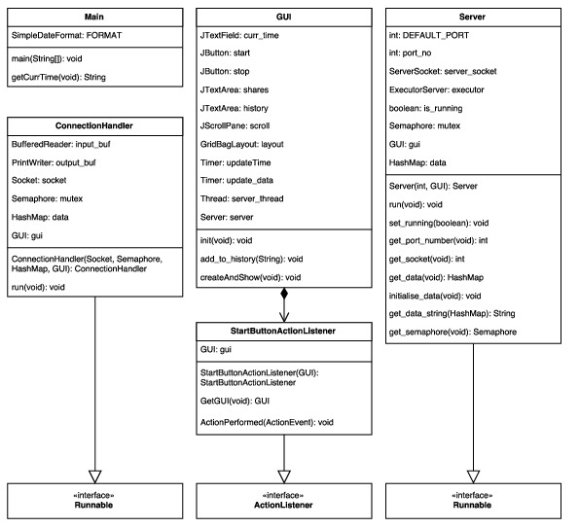
The main() entry point simply calls SwingUtilities.invokeLater() with an anonymous runnable to create and show the GUI, ensuring that all GUI events are put on the Swing EDT (Event Dispatching Thread). The GUI initialises itself, adds action listeners and starts the timers in it’s constructor. When the user clicks the start button, a new thread is initialised with a new Server runnable object, then started. The stop button is enabled, and the start button disabled.

In the Server’s run() method it creates a new ServerSocket, a new executor with a number of threads dependent on the number of cores in the processor executing the program. The server then calls ServerSocket.accept() in a loop to accept any new connections, then delegates them to a ConnectionHandler task which is handled by the executor.

For each incoming connection, a new ConnectionHandler runnable is created and ran. It outputs some information to the user, then performs a blocking read. When the user has input some instructions, it parses the input then applies it to the data, outputs error messages if the input is in an incorrect format, or destroys itself after cleaning up if the user input is “QUIT”.
The data stored by the server is stored as a HashMap, with the key being a string representation of the stock e.g. “SKY” and the value mapped to it the number of stocks left for that index (in a BigInteger format). Since the HashMap class is not thread safe, a single Semaphore object is used to ensure mutually exclusive access to each thread while that thread is in a critical section. Each thread must acquire from the Semaphore before reading or writing (as reading while another thread is writing may produce the wrong output).

Testing

Most testing is done by hand as it is difficult to write test cases for threaded code, particularly when it depends on events being generated by a user with a GUI. The cases I tested are as follows:

1. Mutually exclusive access to critical sections. I tested this by creating a small python script (included in the test package) which uses the pexpect package to send input to a tty. In this case I used it to send commands to the server over telnet. The script sends exactly 2007 “BUY BP 1” commands to the server, with a small timeout of 0.01 seconds. I have also included a small bash script which runs the python script twice simultaneously, meaning that two or more threads will be trying to read/write the data simultaneously. If mutual exclusion is enforced, exactly 1 BP stock should be left after the bash script has finished. This was the case in my testing, however since it isn’t possibly to test every single possible interleaving there may be a case where mutual exclusion is not enforced as I cannot prove my program to be thread-safe.

2. Cleanup after the server has been shut down. I tested this by closing terminal windows without issuing the “QUIT” command, and by stopping the server while tty’s were still connected. While the server cleans up perfectly if a user prematurely ends a session, I could not figure out how to close an existing connection with the stop button. As such, any existing connections will continue until the users ends the session either by closing the tty or by sending the “QUIT” command. Note that while existing connections will continue, no new connections may be made after the server has been stopped.

3. Injection of events to the Swing EDT. This was tested by running the same script described in section (1) and watching the GUI for any evidence of lag, or a failure to refresh. In my testing, the GUI refreshed with an acceptable rate.

4. Validation of user input. I tested this by firstly checking that a correct command e.g. “BUY BP 1” worked correctly. Having verified this, I then moved on to edge cases e.g. “BUY BP 1” with only 1 BP stock left, then on to invalid cases e.g. not issuing a full command, buying with no stocks etc. The program’s output was as desired, correctly buying stocks with valid commands and giving helpful error messages when an incorrect or invalid command was given.

